

Cognizant Technology Solutions

XXXX

Detailed technical design document

|  |  |  |  |
| --- | --- | --- | --- |
|  | **Prepared By** | **Reviewed by** | **Approved By** |
| **Name** | Vansh Thakur(2144435),  Siddharth Kumar(2144362),  Pawan Chauhan(2152304),  Swetant Singh(2152304)  Surabhi Roy Chowdhury(2142019),  Krishnendu Biswas(2141766) |  |  |
| **Role** |  |  |  |
| **Signature** |  |  |  |
| **Date** | 15th July 2022 |  |  |

Table of Contents

Introduction 4

1.1 Purpose 5

1.2 Background 5

1.3 Scope 5

1.4 Assumptions 6

1.5 Background & High-Level Architecture of MDM Solution 7

1.6 Data Flow for MDM implementation 8

1.7 ETL Architecture 8

1.12 ETL MAPPING DIAGRAM 25

1.15 Data Layers in the MDM Architecture 29

❖ MDM Landing tables 29

❖ Base Objects 30

❖ MDM Staging Tables 31

❖ MDM Staging Mapping 33

❖ MDM HUB (INS-360 Data Model) 43

1.16 Informatica MDM Multi-domain Architecture 45

1.17 MDM Informatica Hub Design 46

1.18 Stage Process 47

1.19 Rejection handling in MDM Hub 47

1.20 Cleanse Functions and Mappings 48

1.21 Mappings 48

1.20 Load process 48

1.23 Match Process 49

❖ Match Columns 50

❖ Match Rules 50

1.24 Trust Rules 57

❖ Trust and Survivorship Matrix 57

1.25 Queries and Packages: 61

# Introduction

## Purpose

It provides an overview of how source data will be mastered **to meet business needs of a Bank Service to promote its customer base reaching out to more customers** and the supporting solution architecture. Included in the document are components from Informatica (PowerCenter and MDM Hub Console), Oracle DBMS and a high-level explanation of how these components will interact.

## Background

Development of an Organizational Provider Master will help to build a Golden Record. That fetch data as per the business need of **BANK** will give them a golden record of potential customers.

* Ability to see the entire data source.
* Ability to analyze and understand current provider demographics.
* Create a “Golden Record of Datar” for consumption by users and systems.
* Define agreed upon standard Provider relationship rules for use across the organization.
* Define distinct enterprise definition and business rules for Provider attributes.

## Scope

This TDD covers the Informatica Master Hub (MDM), non-master data, associated ETL and the database designs.

Additional details are provided in later sections of this document but as an introduction, the implementation will include source data that’s been fetched from 3 different sources containing information that will be needed to create our Golden Record as per the business need of the client.

* **SOURCE DATA:** Data from 3 different source systems has been taken

**Source 1: CRM**

**Source 2: Sales**

**Source 3: Retail**

**Containing Similar Attributes as:**

|  |  |  |  |  |  |  |  |  |  |  |  |  |  |
| --- | --- | --- | --- | --- | --- | --- | --- | --- | --- | --- | --- | --- | --- |
| **Customer ID** | **Customer name** | **DOB** | **Address line 1** | **Address line 2** | **City** | **State** | **Zip Code** | **Customer Phone No.** | **Customer Email** | **Occupation** | **Source** | **Country** | **Gender** |

* **ETL Processes**

Informatica PowerCenter will be utilized and all ETL jobs will be developed to acquire and publish the data for further processes in MDM.

* **Informatica MDM**

In Informatica MDM a central Hub will be created. Where the Target Table of ETL will be loaded to the Landing Table which eventually go through staging and loading process to achieve our Golden Copy Data

* **Data Sources for MDM Hub**

The following are the identified source systems that will provide data through a “flat” file data load process (ETL) interface to MDM:

* + - **Customer_Info**
    - **Customer_Contact**
    - **Customer_Address**
* **Publish Data**

This data is a golden copy record of customer details of potential customers needed by the bank to meet their business needs.

## Assumptions

* Source files records will always contain a unique identifier like CUST_ID (Customer ID)
* Source DATA taken in the form of ‘flat files’(.csv) in excel format.
* Access will be available for MDM development.

* All database storage will be in Oracle. (NOT SURE)
* Data that has been gone through the ETL process would only be considered for mastering.
* Data from 3 sources systems would only be integrated to the MDM Hub.
* The Development and Testing would be done in the same environment.
* Informatica PowerCenter would be used as the ETL tool.
* Informatica MDM would be used as the MDM tool.

## Background & High-Level Architecture of MDM Solution

There is currently no single system that contains all of **Bank Customer Detail Information**. Source data information is spread across multiple systems. The business need is to have a single source of accuracy, updated and comprehensive. Customer information that will address inconsistencies/inaccuracies across different source systems. To support these needs a Customer Master has been created.

The illustration below depicts the major components of the architecture. Data will be hosted (staged) in different locations as it moves through the match architecture.

The source data will come to the MDM architecture as database created out of the PowerCenter. ETL will process the data through the integration layer and into MDM. Within MDM there are several layers and processes that manipulate the data further and allow end-users to view and manipulate it. Upon completion of all data processes in MDM a Golden Record will be available for all Customer Information that have been loaded and processed. These will be available to downstream applications and hosted in the “Final Stage” repository.

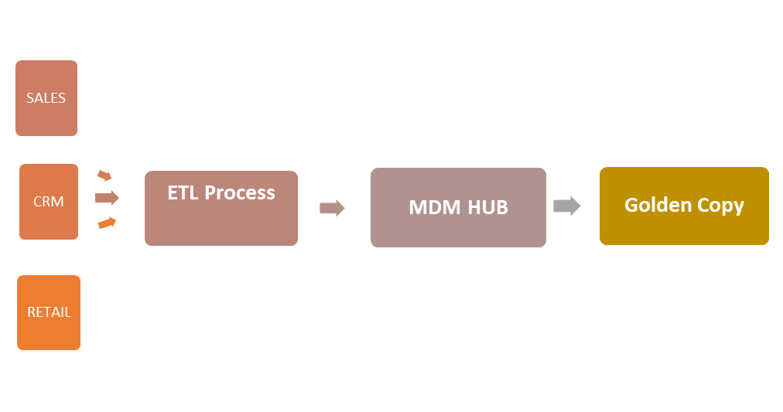

Fig: **DATA FLOW DIAGRAM**

## Data Flow for MDM implementation

The figure below represents the complete data flow diagram from the EDR Subscription Files (Upper Left) through landing areas, MDM and Final Stage.

Power

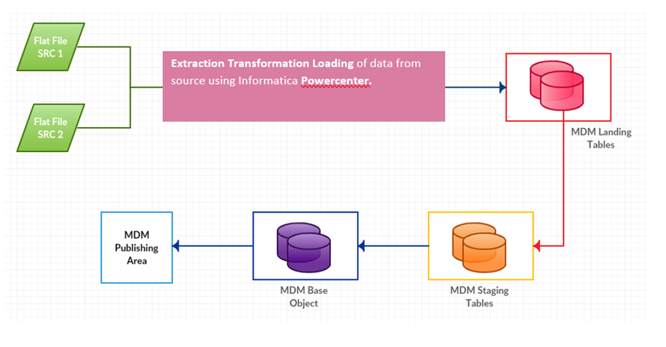

*Fig: Data Flow diagram MDM implementation*

## ETL Architecture

Informatica PowerCenter will be used for all ETL development in support of this project. PowerCenter provides various services and features for data extraction and load. In the transformation part of the ETL, in this project we used the **Expression Transformation** and the **Union Transformation.**

The Expression Transformation is a passive transformation which let us modify individual ports of a single row, or add or suppress them. It helps implement complicated data transforms, applies business logic and performs checks and validations.

Any transformation is called passive when number of input and output rows are the same.

The Union transformation is an active transformation that you use to merge data from multiple pipelines into a single pipeline.

A Transformation is called active when the number of input and output rows are different as they are passed through the transformation.

Below is a diagram that identifies the interaction of various services and databases with Informatica Administrator console.

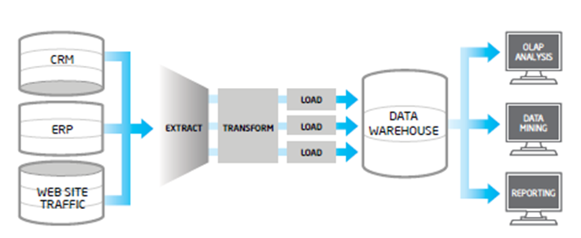

Fig: ETL Architecture

* **ETL SOURCE TABLE**:

Data from 3 different sources are taken CRM, REATIL and SALES as follows named as **crm_source**, **retail_source**, **sales_sources.**

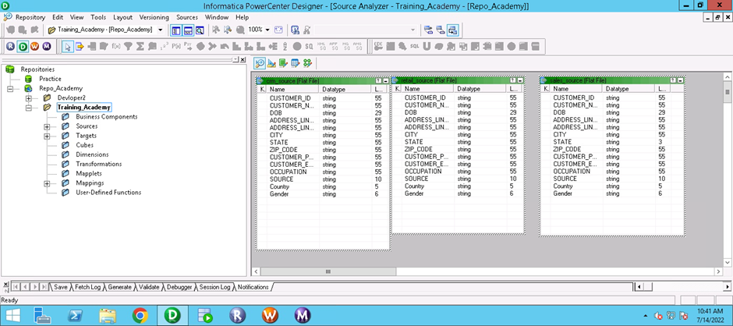

* **TARGET TABLE**:

Three target tables are taken named **cust_info**, **Contact**, **Address** in a flat file format. Through Mapping Source Tables are mapped with Target Tables following different transformation method.

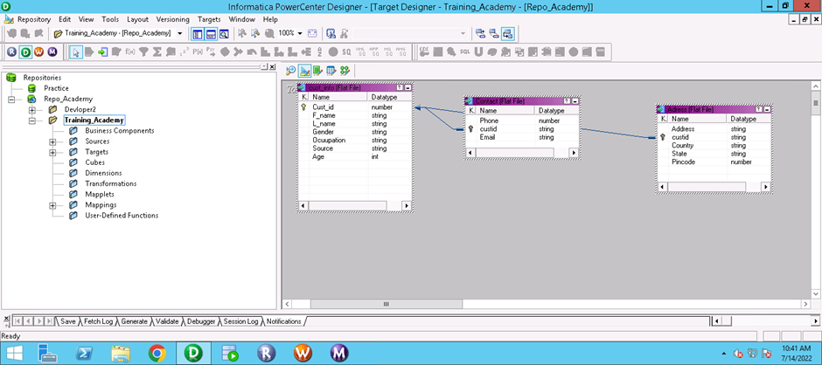

Fig: Target Table

* **ETL COLUMN MAPPING**

In ETL mapping, source was imported as ‘flat file’ in .csv format into the source table of PowerCenter and we have taken 3 sources so there are 3 tables names as **crm_source**, **retail_source**, **sales_sources**.

A filter was created that forwarded the valid data from source qualifier to expression.

Expression Transformation and Union Transformation has been used.

Expression was named as for each source table **exp_address**, **exp_custInfo**, **exp_contact**.

|  |  |  |
| --- | --- | --- |
| **SOURCE TABLE** | **EXPRESSION** | **TARGET TABLE** |
| CRM_SOURCE | Exp_address |  |
| CRM_SOURCE | Exp_custInfo | **Cust_Info** |
| CRM_SOURCE | Exp_contact |  |
| RETAIL_SOURCE | Exp_address | **Address** |
| RETAIL_SOURCE | Exp_custInfo |  |
| RETAIL_SOURCE | Exp_contact | **Contact** |
| SALES_SOURCE | Exp_address |  |
| SALES_SOURCE | Exp_custInfo |  |
| SALES_SOURCE | Exp_contact |  |

* **EXPRESSION DESCRIPTION**:

*Showing Expression Details for on Source table as transformation for the other two source table happens in the same way.*

**FOR SOURCE CRM:**

**ex_address**

|  |  |  |  |
| --- | --- | --- | --- |
| **Port Name** | **DATA TYPE** | **EXPRESSION** | **COMMENT** |
| ADDRESS_LINE_1 | string |  | ONLY INPUT |
| ADDRESS_LINE_2 | string |  | ONLY INPUT |
| CITY | string |  | ONLY INPUT |
| ADDRESS | string | ADDDRESS_LINE_1||” ”||ADDRESS_LINE_2||” ”||CITY | OUTPUT(Combined add_line1, add_line2 and city to get ADDRESS ) |
| STATE | string |  | Both INPUT & OUTPUT |
| ZIP CODE | string |  | Both INPUT& OUTPUT |
| COUNTRY | string |  | Both INPUT & OUTPUT |
| CUSTOMER ID | String |  | Both INPUT & OUTPUT |

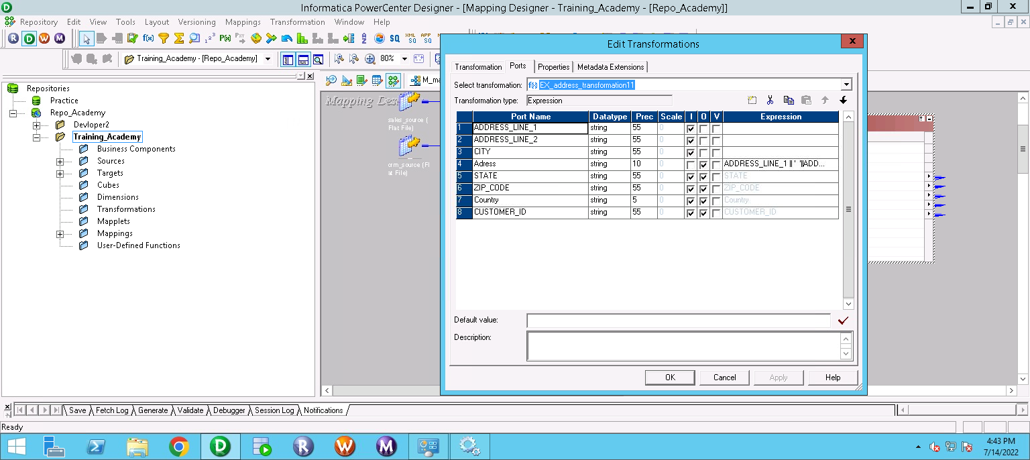

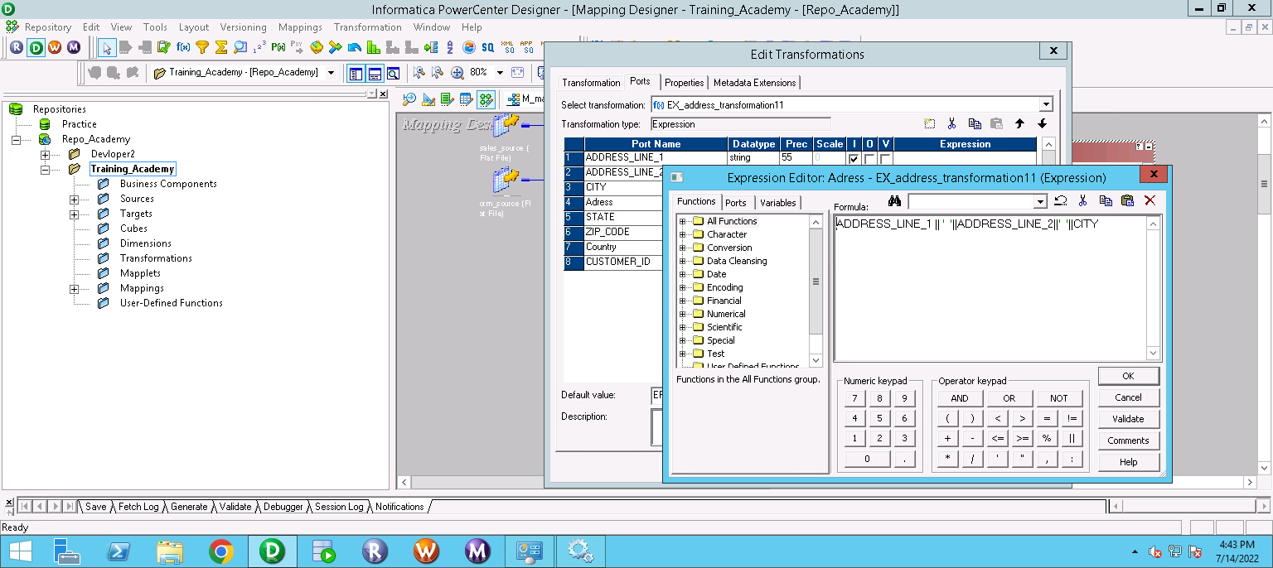

**ex_cust_Info**

|  |  |  |  |
| --- | --- | --- | --- |
| **Port Name** | **Data Type** | **Expression** | **Comment** |
| CUSTOMER ID | string |  | Both IN/OUT |
| .f_name | string | SUBSTR(CUSTOMER_NAME, INSTR(CUSTOMER_NAME, ‘ ’,1)+1,((INSTR(CUSTOMER_NAME, ‘ ’1)-1)-INSTR(CUSTOMER_NAME, ‘ ‘ ,1))) | ONLY OUTPUT (Segregate First name from Customer_Name) |
| .l_name | string | SUBSTR(CUSTOMER_NAME, INSTR(CUSTOMER_NAME, ‘ ’,1)+1) | ONLY OUTPUT (Segregate Last_Name from Customer_Name) |
| CUSTOMER_NAME | string |  | ONLY INPUT |
| OCCUPATION | string |  | Both IN/OUT |
| SOURCE | string |  | Both IN/OUT |
| GENDER | string |  | Both IN/OUT |
| DOB | string |  | ONLY INPUT |
| AGE | integer | (GET_DATE_PART(SYSDATE,’YYYY’)-TO_INTEGER(SUBSTR(DOB,8,4)) | Got age from DOB |

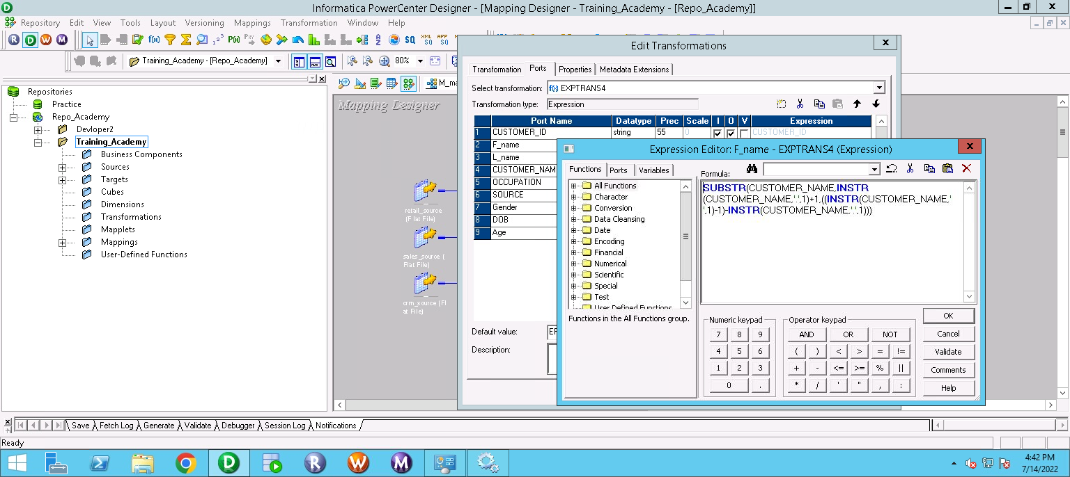

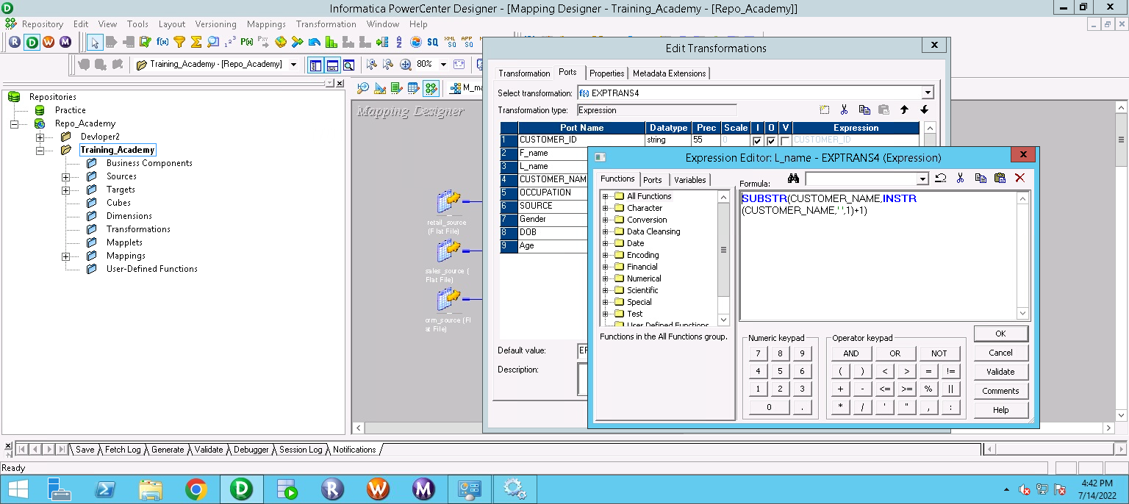

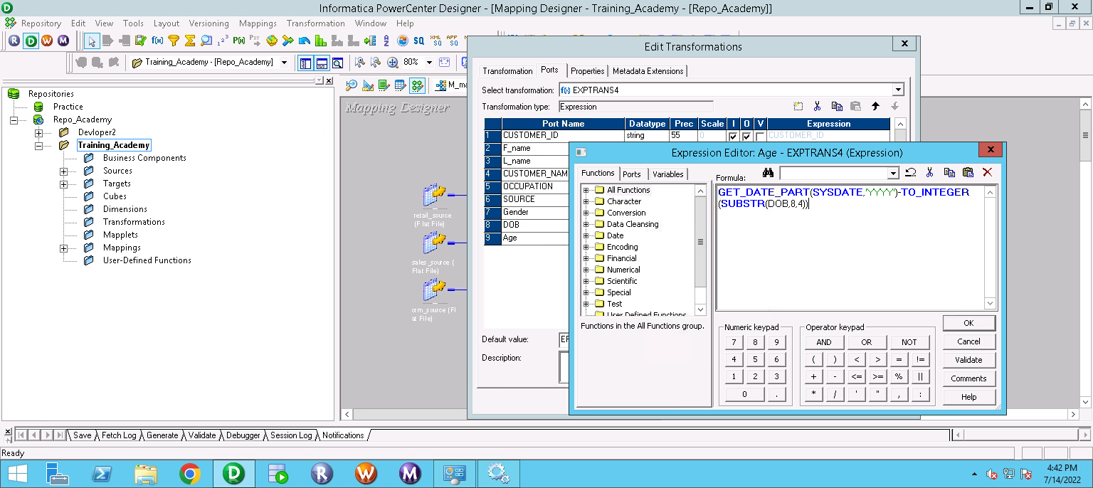

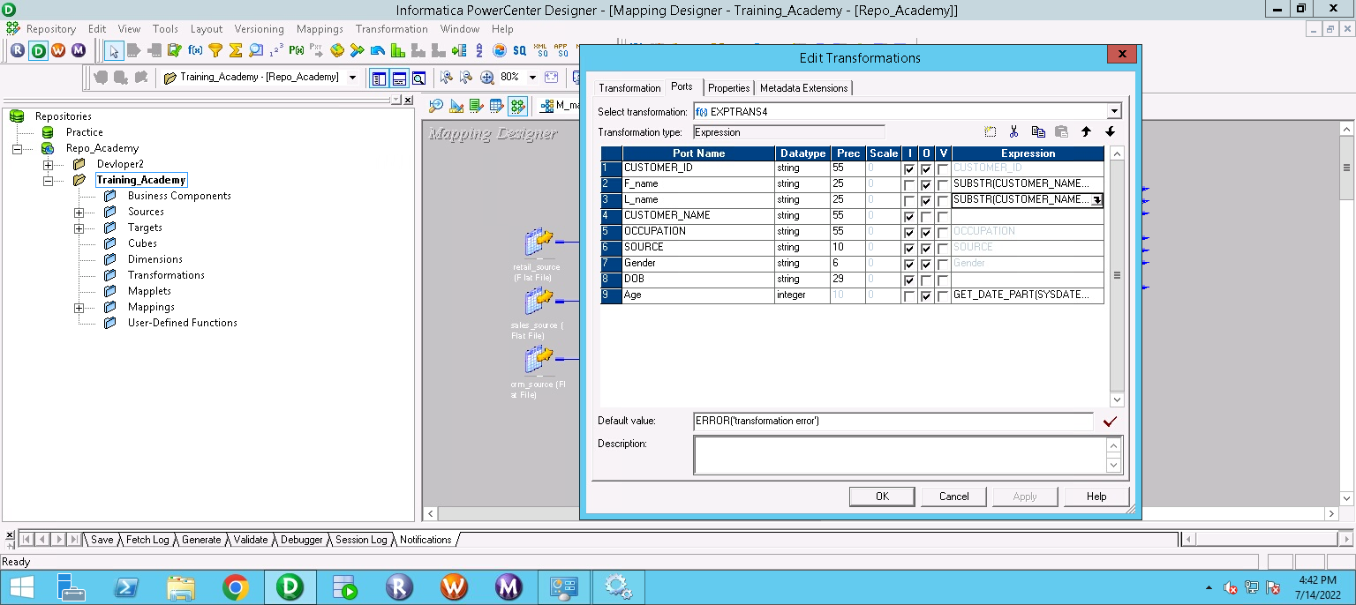

**ex_contact**

|  |  |  |  |
| --- | --- | --- | --- |
| **Port Name** | **Data Type** | **Expression** | **Comment** |
| CUSTOMER_PHONE_No | string |  | BOTH IN/OUT |
| CUSTOMER_EMAIL | string |  | BOTH IN/OUT |
| CUSTOMER_ID | string |  | BOTH IN/OUT |

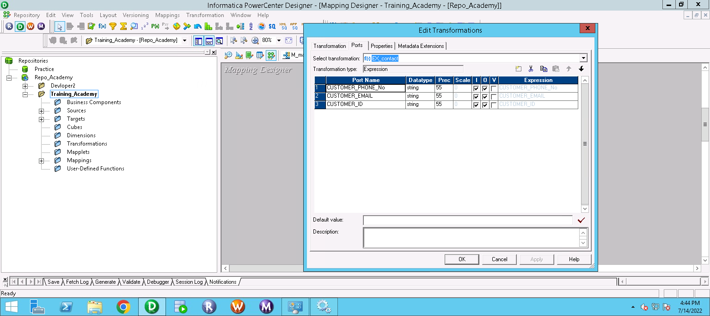

Likewise, same will be done for two other source tables, Retail and Sales. Hence, we will get six such expression tables. Now six of such segregated tables need to be combined hence another transformation is used i.e UNION TRANSFORMATION.

**UNION Transformation:**

Combine multiple similar data sets into a single unordered result set. It is similar to Merge Transformation except it can handle more than two inputs and you do not need to sort the data prior to combining them. Combining above three tables to make one table name **Union** similarly two similar tables will be created **Union_1** and **Union_2.**

**Union (**Defining Customer_info**)**

|  |  |  |
| --- | --- | --- |
| **Name** | **Datatype** | **Description** |
| CUSTOMER_ID | String |  |
| F_name | String |  |
| L_name | String |  |
| OCCUPATION | String |  |
| SOURCE | String |  |
| Gender | String |  |
| AGE | Integer |  |
| **CRM** |  |  |
| CUSTOMER_ID | String |  |
| F_name | String |  |
| L_name | String |  |
| OCCUPATION | String |  |
| SOURCE | String |  |
| Gender | String |  |
| AGE | Integer |  |
| **RETAIL** |  |  |
| CUSTOMER_ID | String |  |
| F_name | String |  |
| L_name | String |  |
| OCCUPATION | String |  |
| SOURCE | String |  |
| Gender | String |  |
| AGE | Integer |  |
| **SALES** |  |  |
| CUSTOMER_ID | String |  |
| F_name | String |  |
| L_name | String |  |
| OCCUPATION | String |  |
| SOURCE | String |  |
| Gender | String |  |
| AGE | Integer |  |

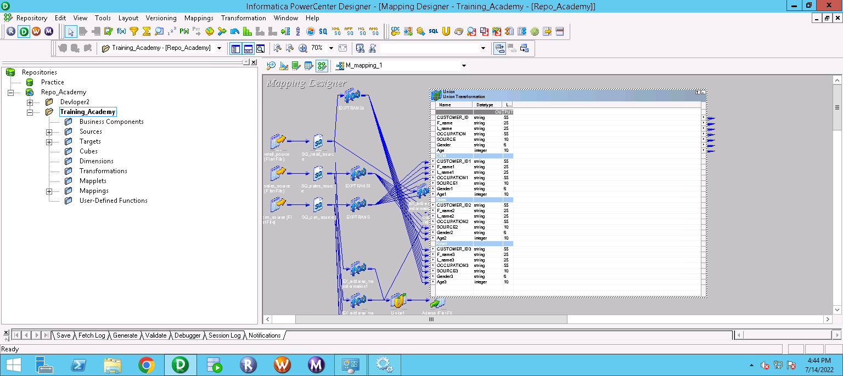

Fig: UNION (Customer_Info)

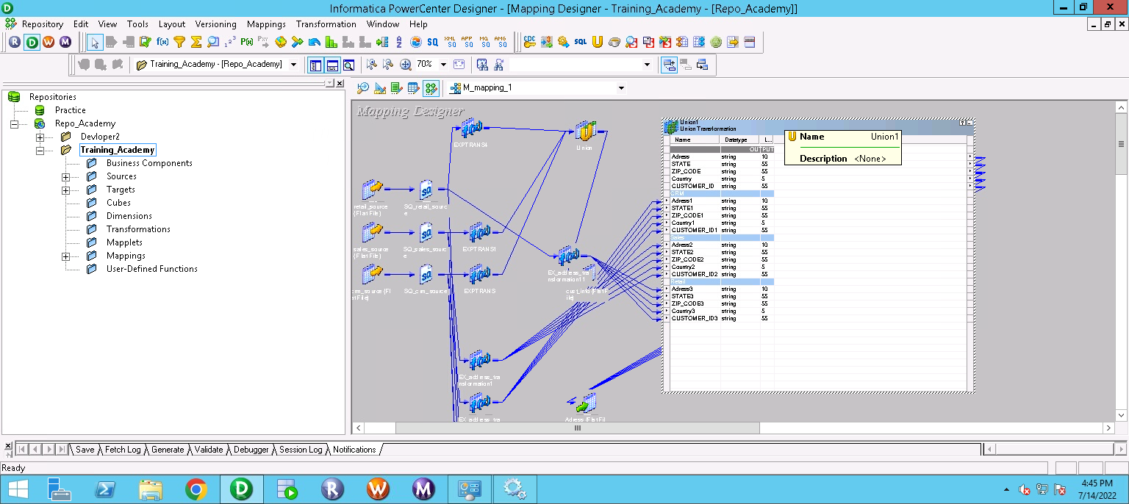

Fig:UNION1(Address)

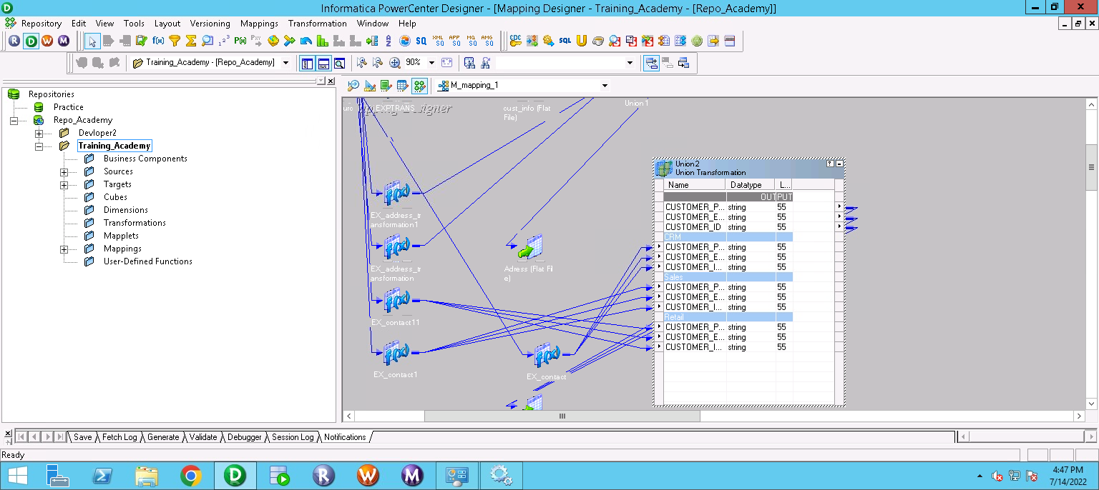

Fig:Union2(Contact)

## 1.8 ETL MAPPING DIAGRAM

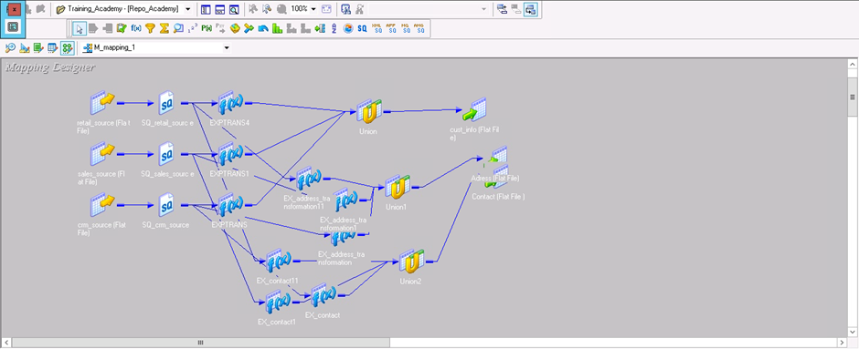

Fig: Mapping Design

* **WORKFLOW**

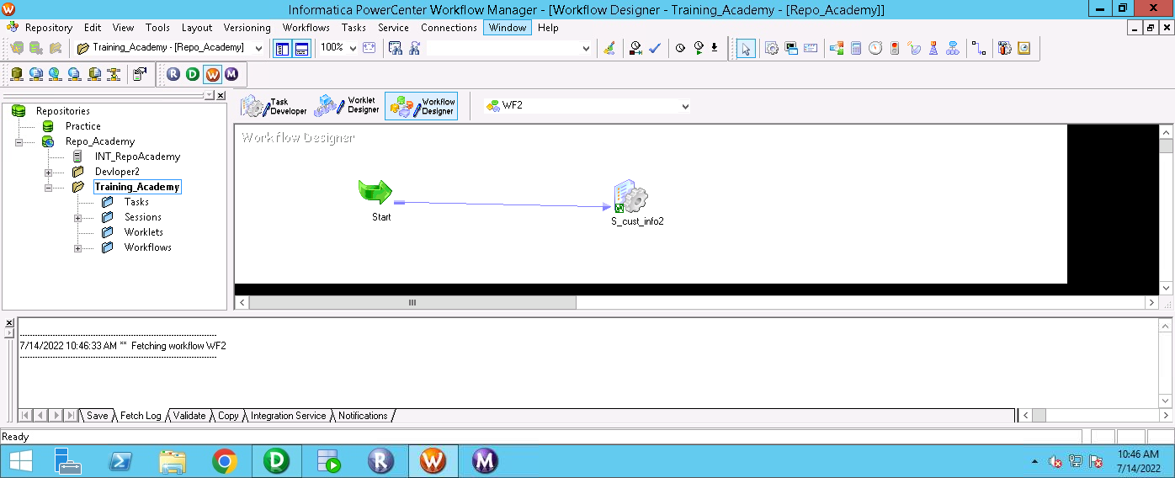

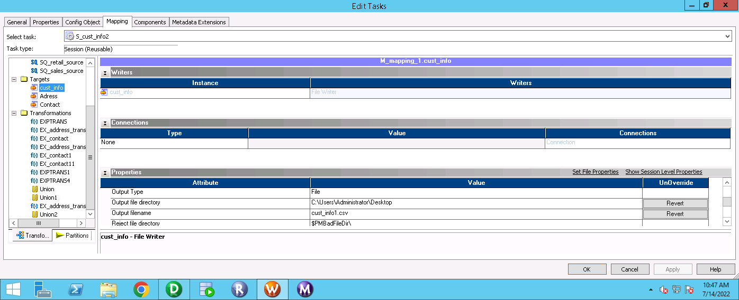

* **MONITOR**

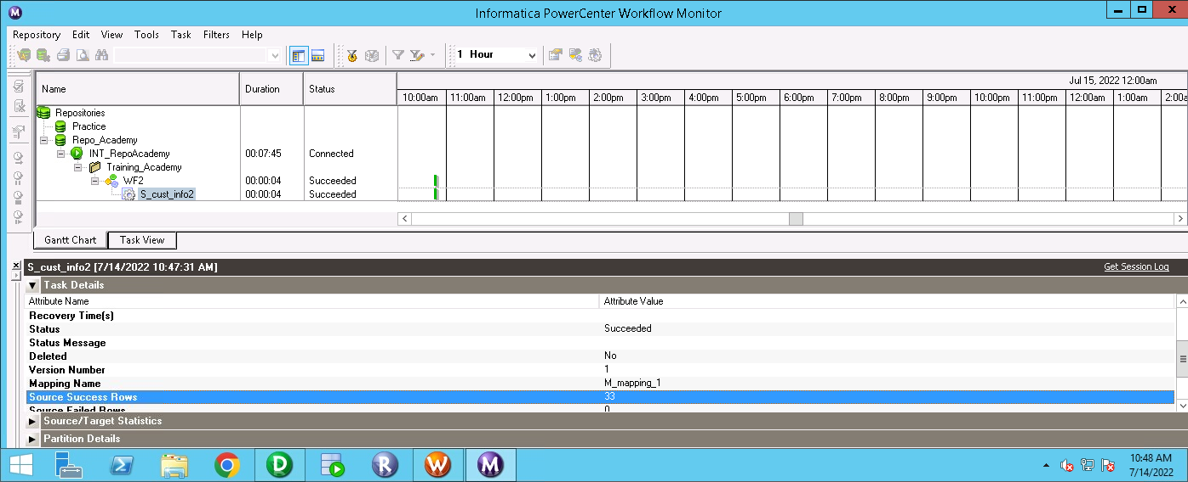

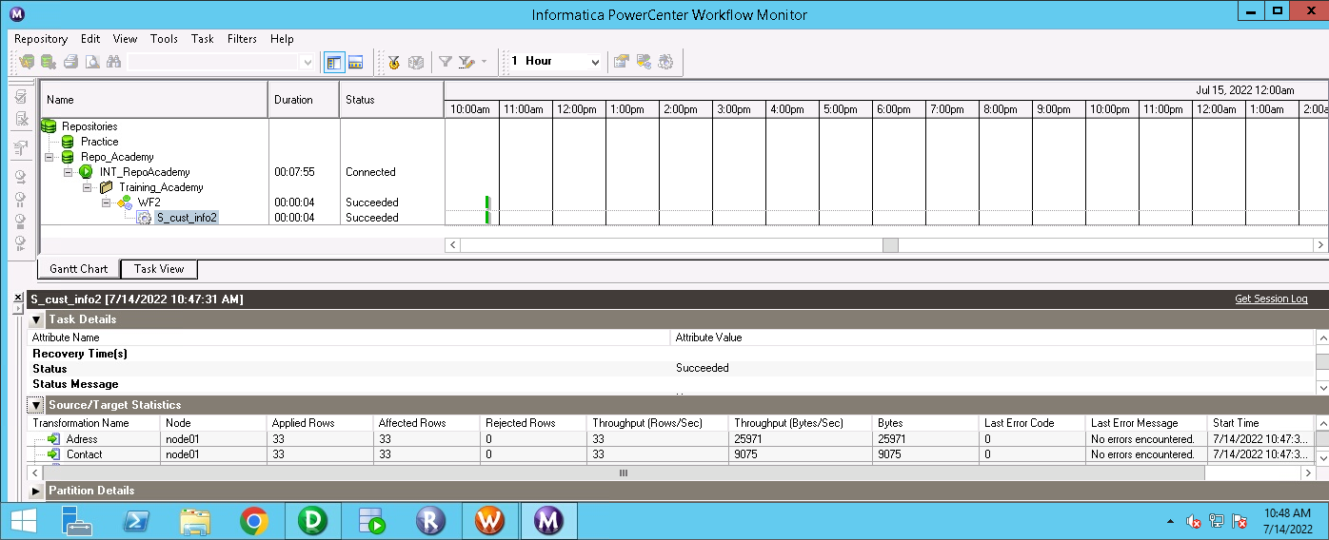

The mapped data in the target tables are the source data for our landing table in MDM Hub. The data are being taken in flat files.

## 1.9 Data Layers in the MDM Architecture

The architecture includes a number of database and file layers that deliver and/or store data. A brief description of each layer is defined below.

The files are:

### MDM Landing tables

MDM landing table are used to store data from ETL in form of Oracle tables. Tables that will be used as landing tables are as follow:

|  |  |  |
| --- | --- | --- |
| **#** | **MDM_LANDING TABLE** | **PHYSICAL NAME** |
| 1 | L_address | - |
| 2 | L_contact | - |
| 3 | L_cust_info | - |

**MDM_LANDING_TABLE:**

1. **L_address**

This table consists of Eight columns:- ROWID_OBJECT(primary key) and last_update_date which is the system generated column, Adress , country, state , country, pincode, which contains Adress related data and Source which has to be store Source name.

1. **L_contact**

This table consists of six columns:-ROWID_OBJECT (primary key)and last_update_date which is the system generated column and cust_id, phoneno, email are stored the contact details of customer and source which has to be store Source name.

1. **L_cust_info**

This table consists of eight columns:-ROWID_OBJECT (primary key)and last_update_date which is the system generated column and cust_id, first_name, last_name, gender, occupation, age stores data related personal information of customer and source which has to be store Source name.

### Base Objects

MDM Base objects will be storing the MDM Master data. A base object is a table in the Hub Store that contains collections of data about individual entities. Each individual entity has a single master record, or “the best version of the truth”, for that entity. An individual entity might have additional records in the base object that contain the “multiple versions of the truth” that need to be consolidated into the master record. Consolidation is the process of merging duplicate records into a single record that contains the most reliable cell values from all of the source records. The base objects has been stored in form of Oracle table. Names and purpose of base object tables are as follow:

The load of Base Objects happens through the Staging Tables. So, for example, if two source systems have data to be loaded into a given Base Object, there will be two Staging Tables associated to that base Object. The data always come from a Landing Table and is mapped to the Staging Tables into the Staging Process Mappings.

A single Base Object has several internal/system tables to collect rejected data, keep historical data, control the loads, keep cross-reference data, and so on.

After the load of the Base Object, a tokenize process starts. This process generates match tokens that will be used subsequently by the match process to identify candidate Base Object records for matching

|  |  |
| --- | --- |
| Base object name | Physical table name |
| B_Adresss | - |
| B_Contact | - |
| B_Customer | - |

### MDM Staging Tables

Staging tables are derived from a combination of the base object tables and landing tables. The columns within the staging tables will mimic that of the base object tables. However, the data to populate the staging tables will come from the landing tables.

It is supposed to exist one staging table for each source system that has information to load in the Base Object.

Staging tables used for the purpose of this project are as follow:

|  |  |
| --- | --- |
| **Sr No** | **Staging Tables** |
| 1 | S_CRM_ADDR |
| 2 | S_SALES_ADDR |
| 3 | S_RETAIL_ADDR |
| 4 | S_CRM_CONTACT |
| 5 | S_SALES_CONTACT |
| 6 | S_RETAIL_CONTACT |
| 7 | S_CRM_CUST |
| 8 | S_RETAIL_CUST |
| 9 | S_SALES_CUST |

**MDM STAGING TABLES**

1. **S_CRM_ADDR**

In the staging table data has been split based on the source. This table has the provider details having source State Roaster KY Org.and This table is used to retrieve contact details of the provider including ADDRESS_LINE_1, ADDRESS_LINE_2, CITY, STATE, etc. The table has columns ROWID_OBJECT and last_update_date which is the system generated column, And Adresss, country, State, pincode which contains

Adress related data of customer.

1. **S_SALES_ADDR**

This table contains same column as S_CRM_ADDR but source is different.

1. **S_Retail_ADDR**

This table contains same column as S_CRM_ADDR but source is different.

1. **S_CRM_CUST**

This table consists several columns:-ROWID_OBJECT which is the system generated primary key, and generated other system columns like last_update_date, pk_source_object, etc and Bussiness are cust_id, first_name, last_name, gender, occupation, age.

1. **S_SALES_CUST**

This table contains same column as S_CRM_CONTACT but source is different.

1. **S_RETAIL_CUST**

This table contains same column as S_CRM_CONTACT but source is different.

1. **S_CRM_CONTACT**

This table is used to retrieve contact details of the provider including phoneno, Email AND CUST_ID and some other system columns.

1. **S_SALES_CONTACT**

This table contains same column as S_CRM_CONTACT but source is different.

1. **S_RETAIL_CONTACT**

This table contains same column as S_CRM_CONTACT but source is different

### MDM Staging Mapping

The logic to load data into the Staging Tables, coming from the Landing Tables, is designed into the Mappings. For each mapping, one (and only) Landing Table is read and the rules to load data into the Staging table are applied. We have one Staging Table for each Source System, for each Base Object.

|  |  |
| --- | --- |
| **Sr No** | **Mapping Tables** |
| 1. | M_CRM_ADDR |
| 2. | MAP_CRM_CONTACT |
| 3. | MAP_CRM_CUST |
| 4. | MAP_RETAIL_ADDR |
| 5. | MAP_RETAIL_CONTACT |
| 6. | MAP_RETAIL_CUST |
| 7. | MAP_SALES_ADDR |
| 8. | MAP_SALES_CONTACT |
| 9. | MAP_SALES_CUST |

**Mapping Name:** M_CRM_ADDR

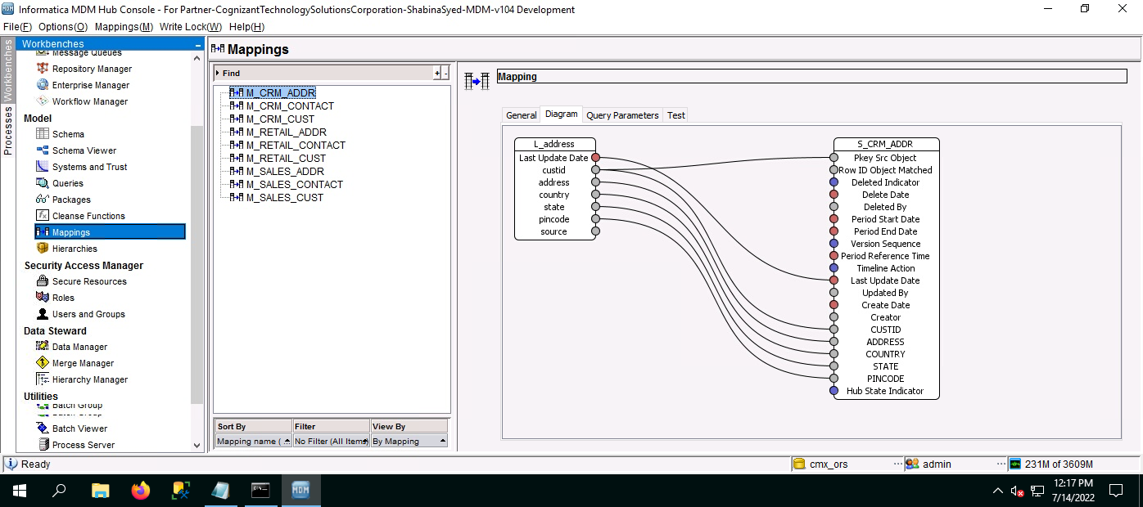

**Mapping Name:** MAP_CRM_CONTACT

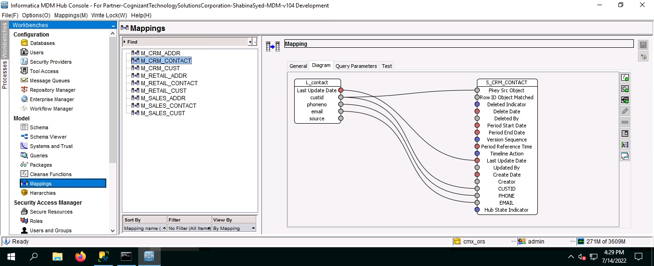

**Mapping Name:** M_CRM_CUST

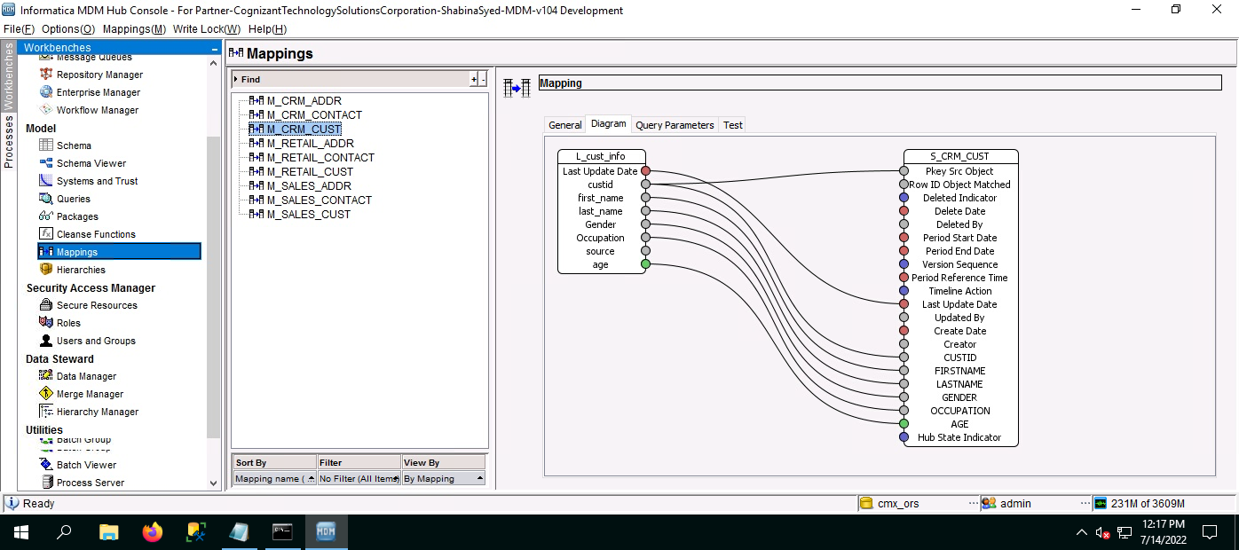

**Mapping Name:** M_RETAIL_ADDR

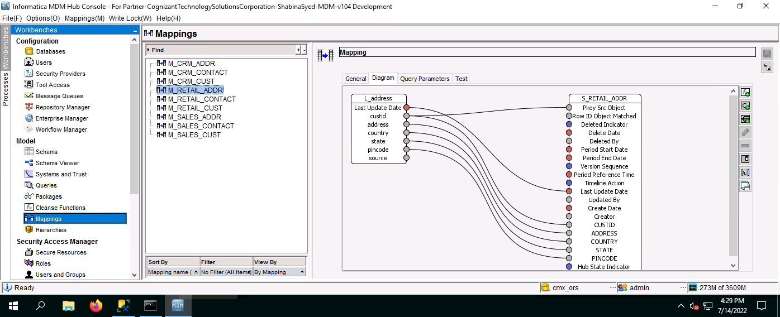

**Mapping Name:** M_RETAIL_CONTACT

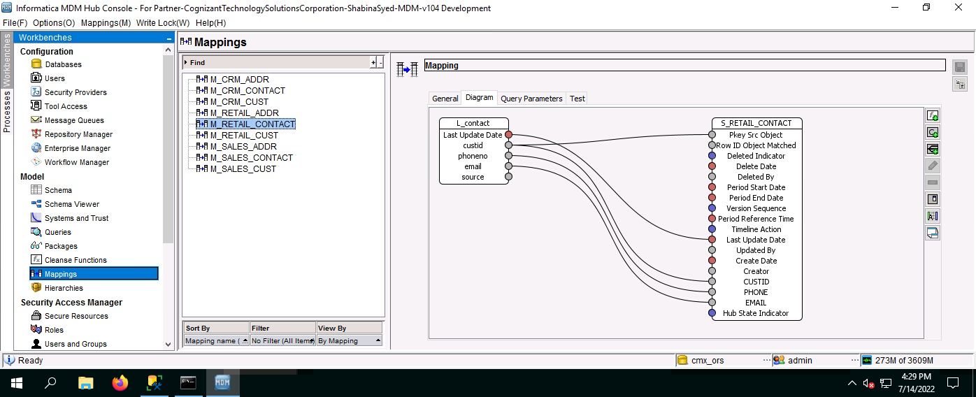

**Mapping Name:** M_RETAIL_CUST

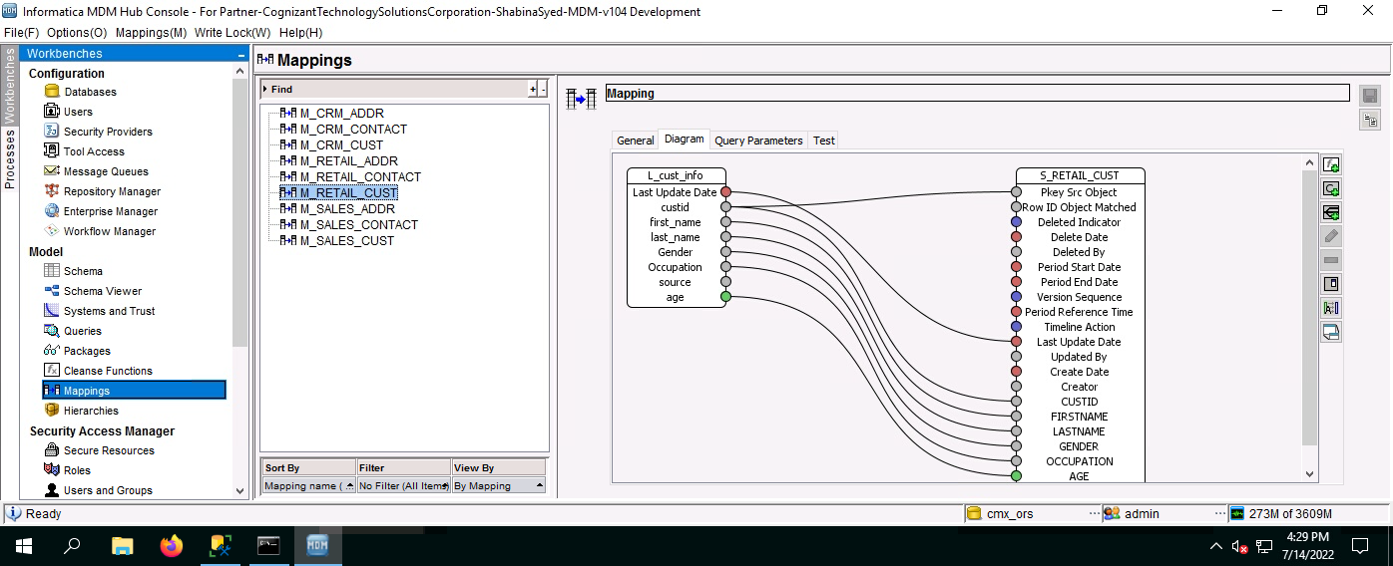

**Mapping Name:** M_SALES_ADDR

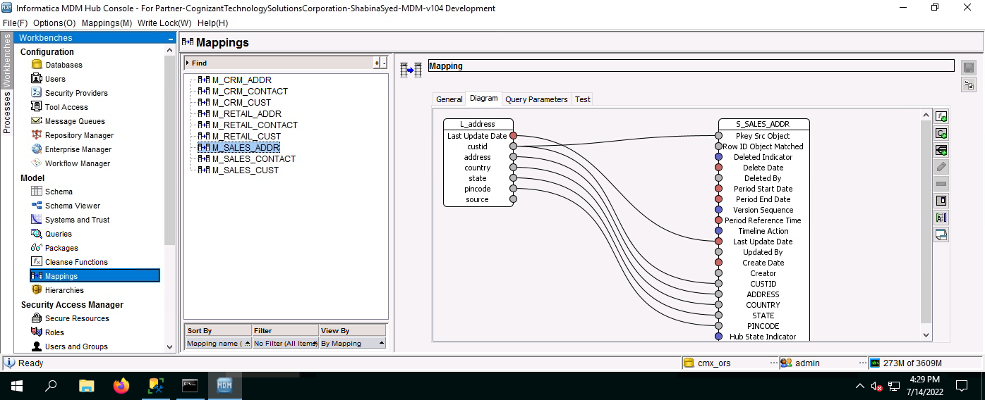

**Mapping Name:** M_SALES_CONTACT

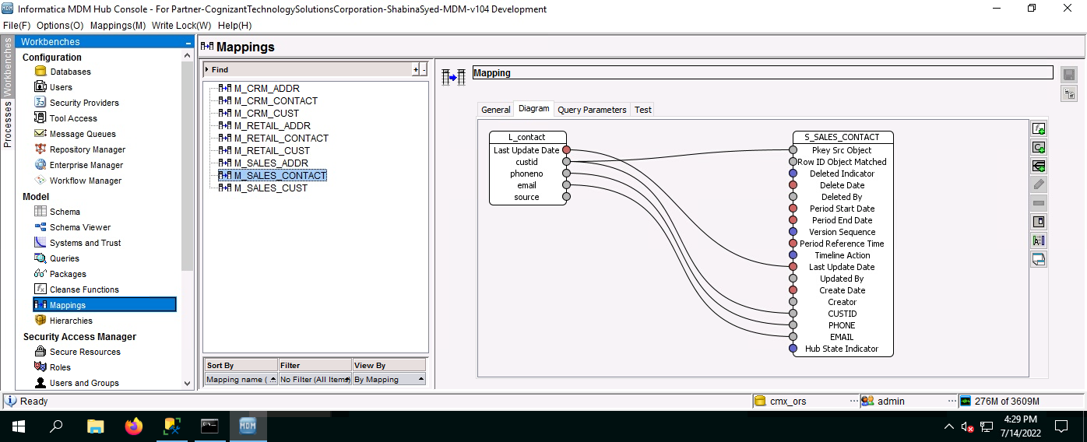

**Mapping Name:** M_SALES_CUST

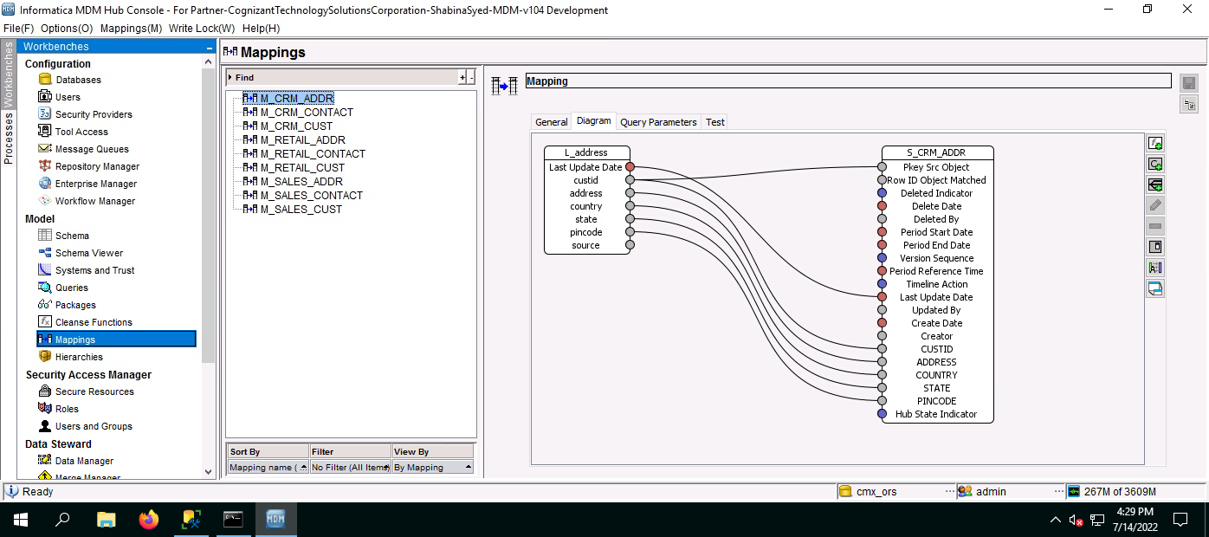

### MDM HUB (INS-360 Data Model)

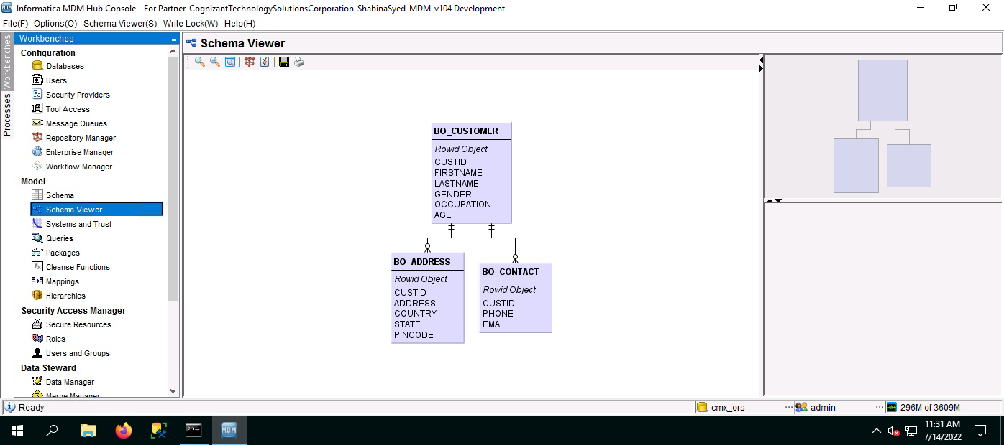

In order to consolidate critical Customer attribute spread across multiple systems, and to provide 360 degree view of Customers, Cognizant Insurance 360 Data model will be leveraged in HealthFirst MDM implementation. As depicted below, Insurance 360 data Model which will be used as the base line. All the objects colored in Pink are out of scope for Phase of MDM implementation.

**Figure: MDM 360 Deg View 1**

* **STAGE AND LOAD PROCESS**

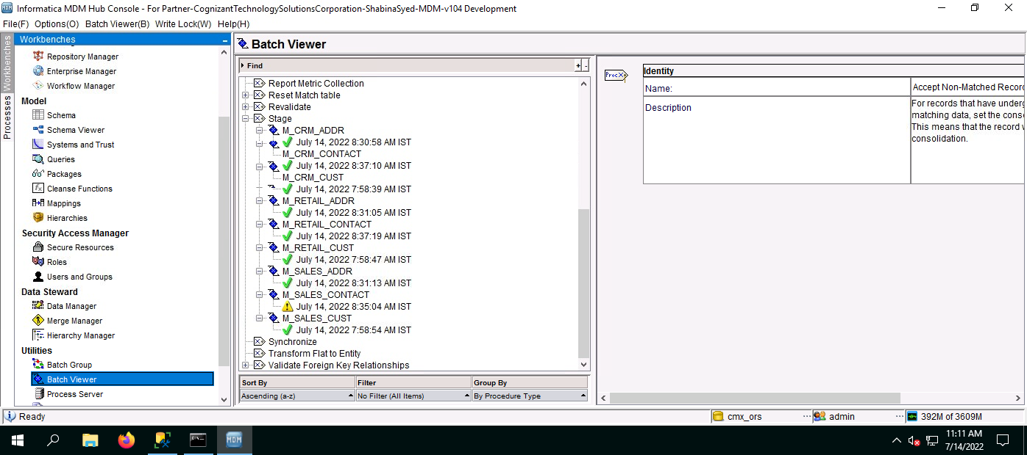

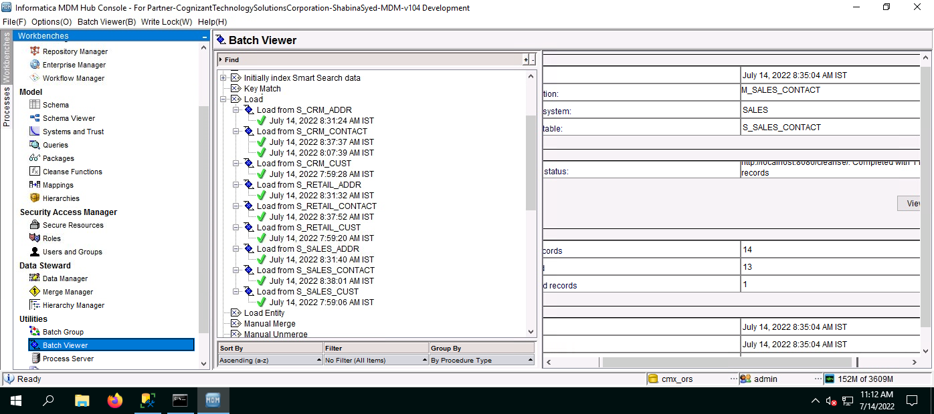

#### MDM Landing Tables

Based on Insurance 360 model, Landing tables are being created. A landing table provides intermediate storage in the flow of data from source systems into Informatica MDM Hub. MDM Landing tables are “where data lands” prior to additional MDM data processing. MDM Landing consists of a set of landing tables designed to cater to data loads from all the identified sources. The landing tables for the Customer Master will be similar to Pre-Landing. They are also structured similar to the MDM Base Objects (tables), thereby having a similar data model. Below is the initial set of tables.

#### MDM Staging Tables

A staging table provides temporary, intermediate storage in the flow of data from MDM landing tables into MDM base objects. Staging tables contain data from only one trust system and are populated from the Landing tables using the Stage processes. Staging tables are subsequently used to load data into a base object. The structure of a staging table is directly based on the structure of the base table that will contain the consolidated data. Each source providing data to MDM will have its own unique trust system. The trust system name is abbreviated with a code, and this code will be used as part of the staging table name. The same staging tables will be used for both IDL and incremental loads. MDM Table names and trust system abbreviations will be provided in a future release of this document.

#### Base Object Tables

These are used to store data for a central business entity (such as customer, product, or employee) or a lookup table (such as country or state). In a base object, data can be consolidated from multiple records (multiple source systems and/or even from the same source system). Trust settings are used to determine the most reliable value of each base object attribute. The trust settings correspond to the trust systems configured in MDM. MDM will define the relationships between base objects. Each base table has several supporting base tables which keep copies of the data. These supporting tables are used for history, trust/survivorship, contributing records. MDM does the configuration of all supporting tables automatically at the time of Hub configuration.

## 1.10 Informatica MDM Multi-domain Architecture

Informatica MDM Multi-domain has J2EE based 3-tier architecture and is being deployed on Windows OS. The first tier is the database, which will be Microsoft SQL Server. Two MDM applications, the MDM Application Hub Server and MDM Process Server, are deployed i. The 3rd layer is the client layer. This layer consists of the MDM Admin Hub Console and the Informatica Data Director (IDD). The MDM Admin Hub Console is a thick client which is used by MDM Administrators and Configurators. IDD is a web based application that has a configuration portal and a separate portal for data stewardship.

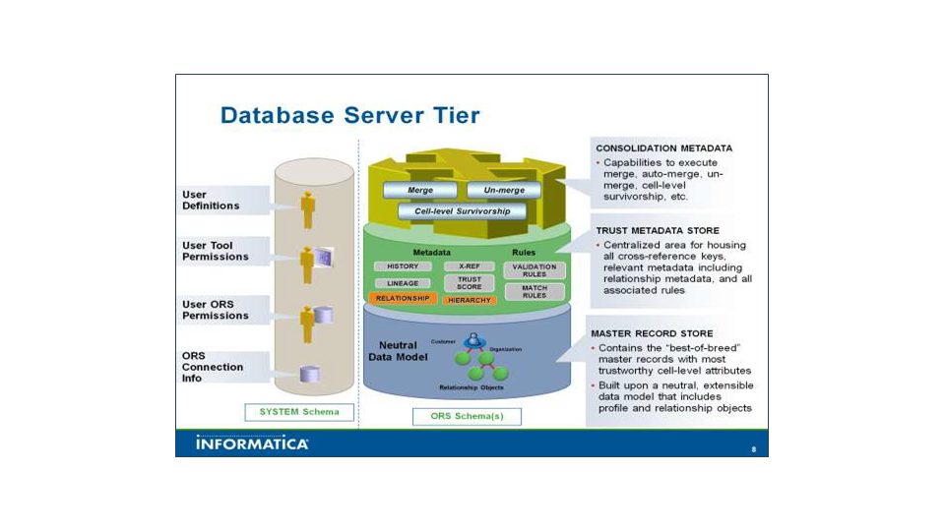

## 1.11 MDM Informatica Hub Design

MDM moves data through series of tables via internal processes. ETL processes insert data into the MDM Landing tables. Data will be flowing from Landing tables to the Base objects via Staging tables. There are Stage and Load jobs facilitating the movement of data. This section is intended to give a high level understanding of the Informatica Hub components and features that are part of the Provider Master architecture.

## 1.12 Stage Process

Staging tables are a bridge between the Landing tables and the entity base objects defined in the MDM hub data model. Staging tables will be populated from landing tables by stage jobs. Each base object in the MDM hub data model will have at least one staging table for each source system. For the HealthFirst Provider Master implementation, each data source is mapped to a single trust system, therefore the Staging tables contain data from one source system. No data transformations, standardizations and cleansing will occur inside the MDM Hub.

Data may get rejected automatically during the Stage jobs for the following reasons:

* Invalid Value if country is not USA
* Duplicates found in PROV_FK.
* Invalid value if NPI does not start with 1 and comprises of 10 valid digits.
* Invalid value if Tax Id is not 9 valid digits.

If rejected, a record would be written into reject table which corresponds to the staging table, i.e. there is not one reject table in MDM. MDM rejects can be viewed in the MDM Admin Hub Console.

## 1.13 Rejection handling in MDM Hub

Reject tables within MDM are populated with the rows that could not be inserted into a staging table (after performing the specified cleansing on a row in the specified landing table) as well as those which could not be loaded into the Base Objects (after executing the load process).

Both staging and load rejects are stored in the same reject tables. The reject tables are tied to the staging tables; these are tied to trust systems. So, for a single data entity there could be multiple reject tables.

Informatica MDM as a product does not provide a reject report but maintains the reject table which can be viewed from the Admin Hub. Apart from the staging rejects, rejects may also occur during the load process. The load process performs foreign key look up and automatically rejects records for the following reasons:

* records with invalid foreign key values
* records with NULL foreign keys
* records with invalid lookup values
* records with null values in mandatory fields

## 1.14 Cleanse Functions and Mappings

Data cleansing is the process of standardizing data. Cleanse functions are a key concept in data cleansing. A cleanse function is a function that is applied to a data value to standardize or verify the data. Data cleansing occurs inside Informatica MDM Hub, specifically during a Stage job, when data is populated from landing tables to the appropriate staging tables.

In current scope of RIM project, the cleansing and standardization of data will be performed in ETL layer using IDQ mapplets.

## 1.15 Mappings

In MDM layer, mappings will be created in the Stage process. The following points will be referred to during MDM mapping creation

* Mappings will be defined to move data from the Landing table to the Staging table
* One mapping would be created for each Landing – Staging table combination. Mapping defines the landing table column which is used to populate a column in the staging table
* In addition to the column mappings, the mapping will have a filter criteria based on the column SRC_SYSTM to only pick records for a specific source system
* No transformation logic will be applied in the mapping during Stage process
* The mapping names will be prefixed <“MP_PRS_PROV_<Staging Table name>”>

## 1.16 Load process

Informatica MDM Loadprocess loads data from the staging tables into the corresponding MDM base tables. Each base table in the MDM hub is referred to as a Base Object.

The following key changes can happen at the end of a load process:

* New records will be inserted in the base object
* New records will be inserted into the Cross Reference table (supporting table used to maintaining contributing records)
* Changed records have been updated in the Cross Reference
* Changed records have been updated in the Base Object depending upon trust settings.



**Diagram: Initial Data Load**



**Diagram: Incremental Load**

During load process, if the new data overlaps with existing data in the MDM hub, the tool uses trust rules to determine which value will survive on the consolidated base record. All data changes are kept in cross-reference or history tables.

In MDM Hub, Records get loaded into Base Objects after the load Process. Following is the Base Objects list that is created in MDM Hub:

## 1.17 Match Process

The process of comparing records to determine if they are potentially duplicates of each other is called matching.

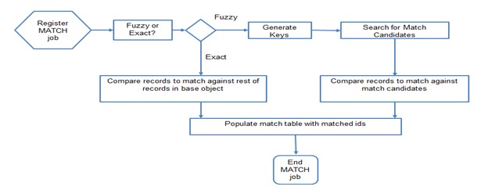

**Diagram: Match Process**

* **Match Paths**

A match path is a flow from parent table to the child table and so on.

### Match Columns

A match column is a column that can be used in a match rule or in a search match. Match columns can be defined as *exact* or *fuzzy*. Exact columns provide deterministic matching and do not allow variations in the data. Fuzzy columns provide probabilistic matching and allow for variations in spelling, format, nicknames etc. Before use of a column in rule definitions, the column should be designated such that it can be used in match rules and information should be provided about the data it contains.

In order to facilitate matching ‘similar’ data that belong to the same class and type, match columns need to be defined first. Exact match columns act as a filter in the match rules and have additional properties when used in match rules like null-match, non-equal match and segment match. Party records are categorized as Person and Organization in the Party table. Segment matching supports having separate match rules for Person and Organization.

The following columns have been identified as potential match columns:

### Match Rules

A match rule defines the criteria by which Informatica MDM Hub determines whether two records in the base object might be duplicates. Match rules are created in the MDM Hub Console and combine various match columns from the base object as well as comparison thresholds for each column.

There are a number of ways to approach creation of the match rules but typically the match threshold varies for different columns from one rule to the other. The match rules are ordered with the highest confidence rules first. Initially Null to Not Null match will be enabled for Middle name. Based on the Match result this option will be reviewed to determine if it needs to be kept. For rules there are two types: Auto and Manual. We are using Auto rule in MDM. With Auto Match Rules the system will tag the records as matches and pass them to the merge process.

The following tables show the proposed, initial match rules to be used for matching the data in the Base Object tables. Match Rules will likely need to be adjusted (match tuning) as data is loaded into the Healthfirst Provider Master.

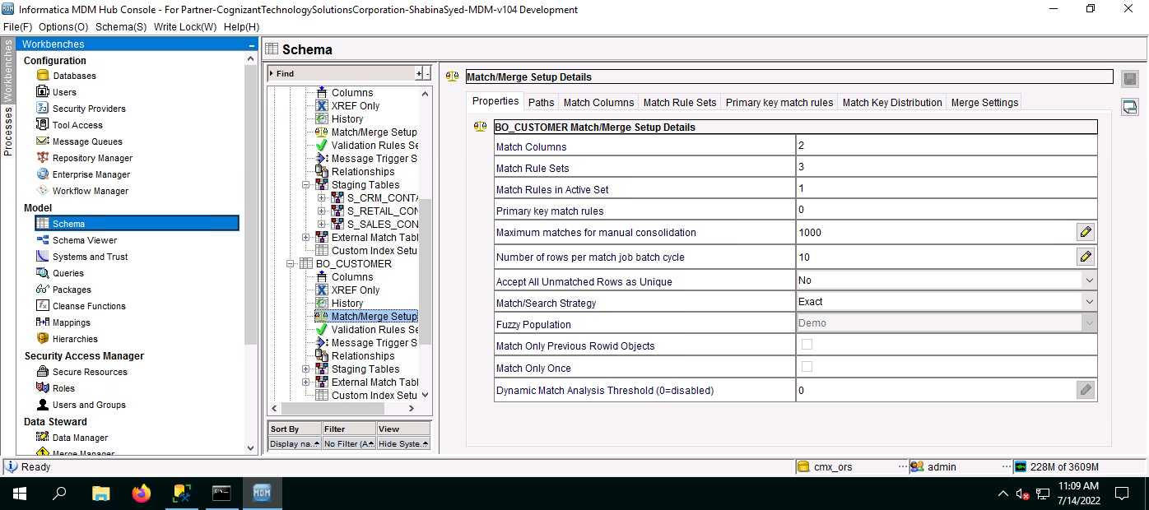

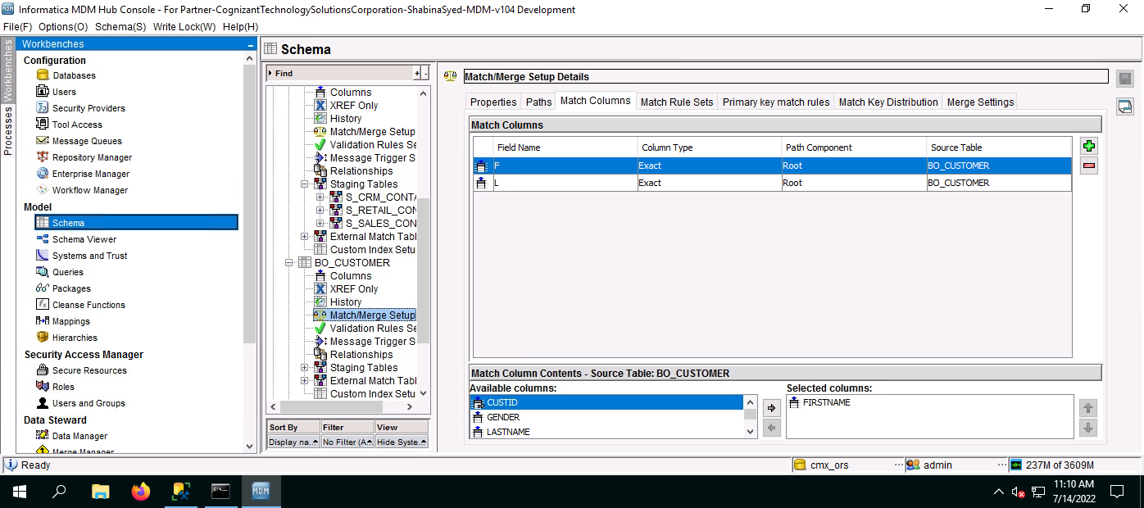

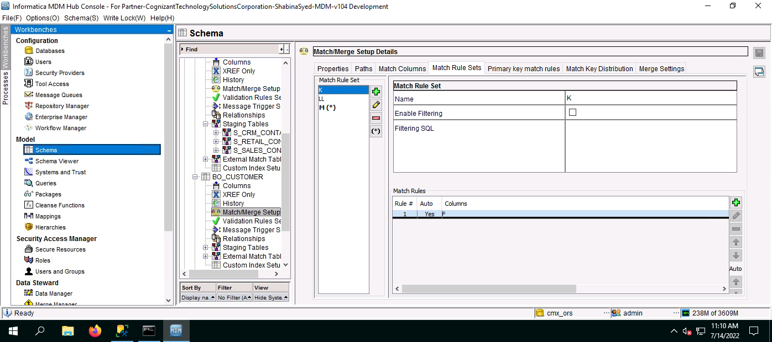

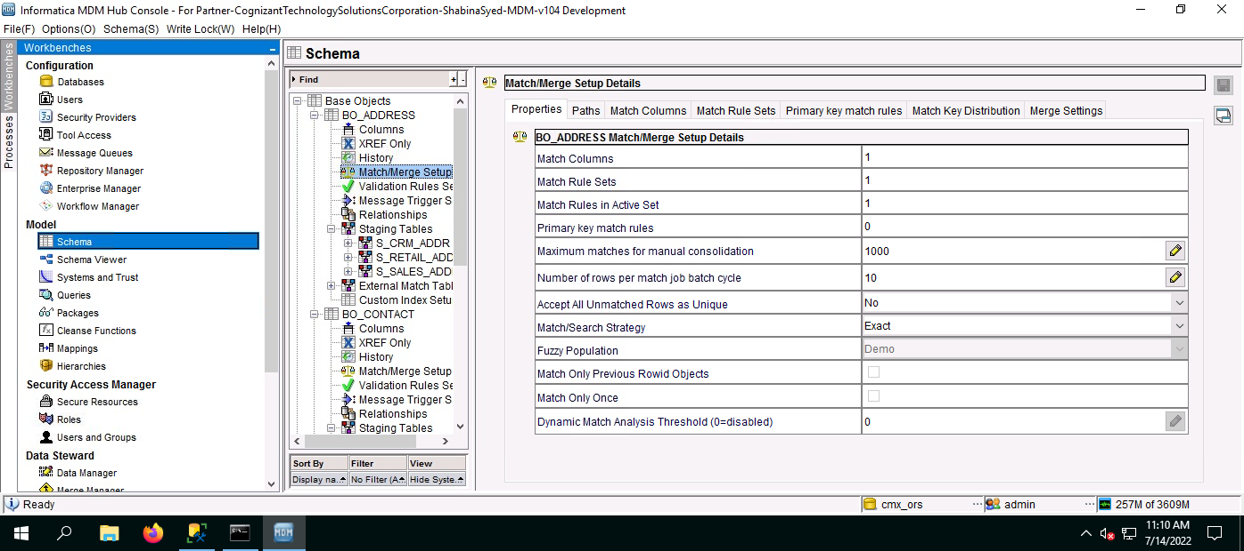

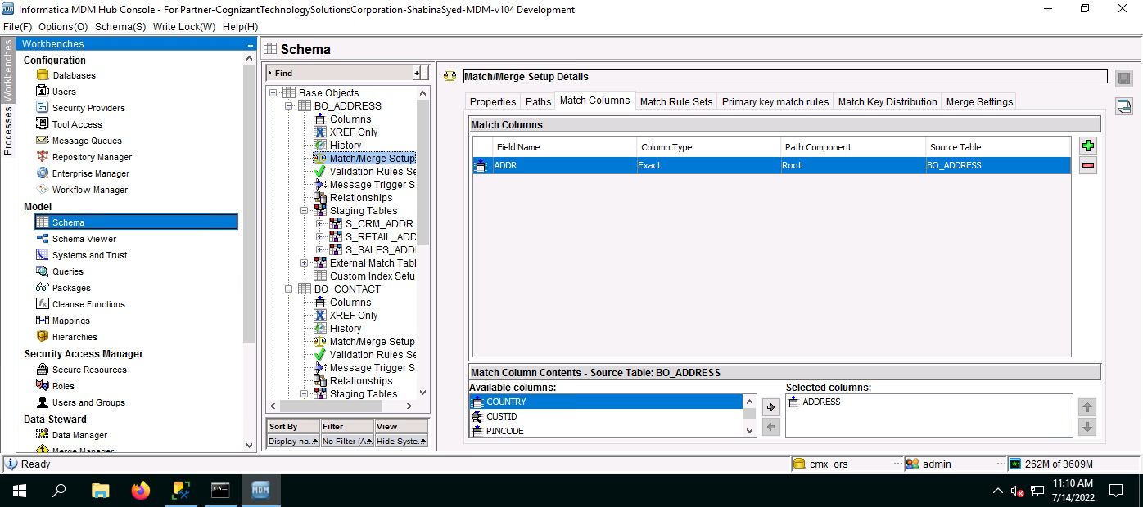

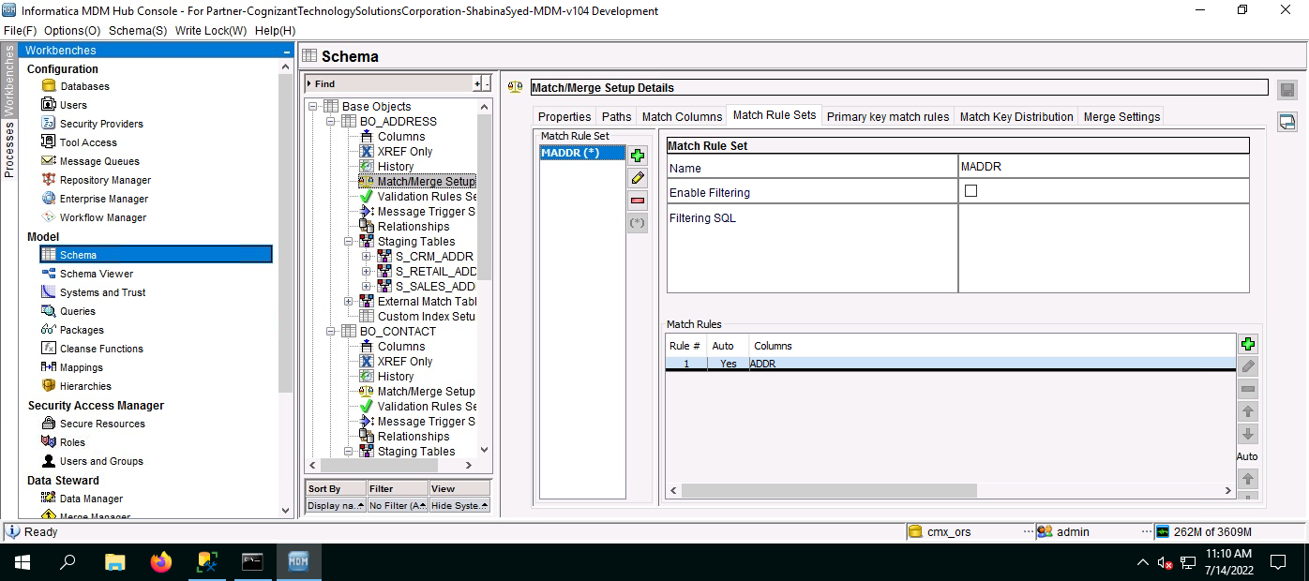

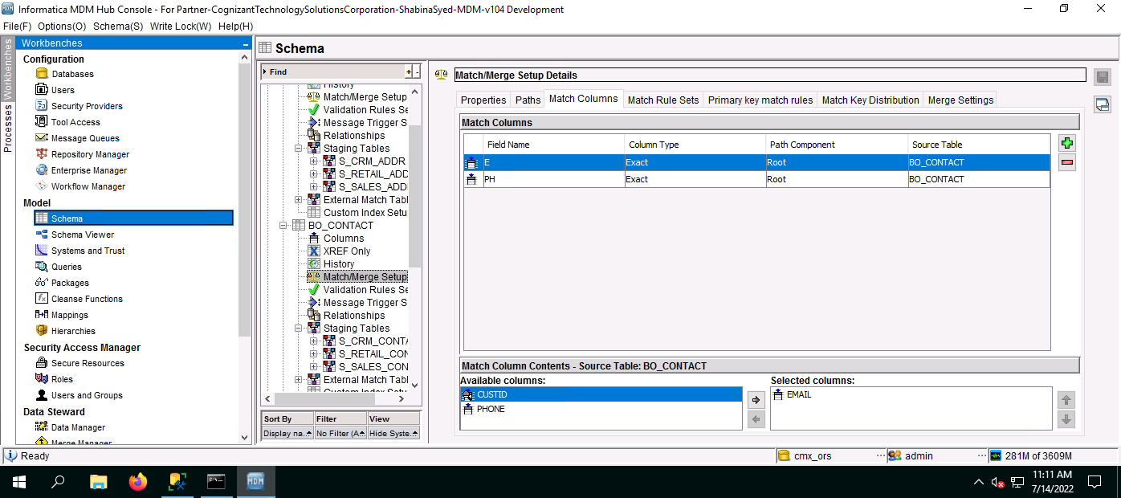

## 1.18 Trust Rules

### Trust and Survivorship Matrix

Trust takes into account known data quality and data deficiencies and other factors such as the age of data, how much reliability decays over time, and the validity of the data. Trust is used to determine survivorship (when two records are consolidated), and whether updates from a source system are sufficiently reliable to update the master record.

When evaluating attributes to merge from two records, Informatica MDM Hub determines which of the contributing (MFRP) record’s attributes should survive in the base record. The surviving attribute data is the best version of the truth across the contributing (MFRP) records.

The table below lists the source systems supplying data to HealthFirst MDM and initial trust values for different columns. The Trust system for Address, Phone & Email will be based on State Roaster KY Org.The ADMIN is the default MDM system whose trust value is used if the Data Steward does a manual update on the record. This means that manual updates will have the highest (most trusted) level within the HealthFirst Provider Master.

|  |  |  |  |
| --- | --- | --- | --- |
| **Attribute** | **CRM** | **SALES** | **RETAIL** |
| Firstname | 80/30 | 70/30 | 90/30 |
| Lastname | 80/30 | 70/30 | 90/30 |
| Occupation | 80/30 | 70/30 | 90/30 |

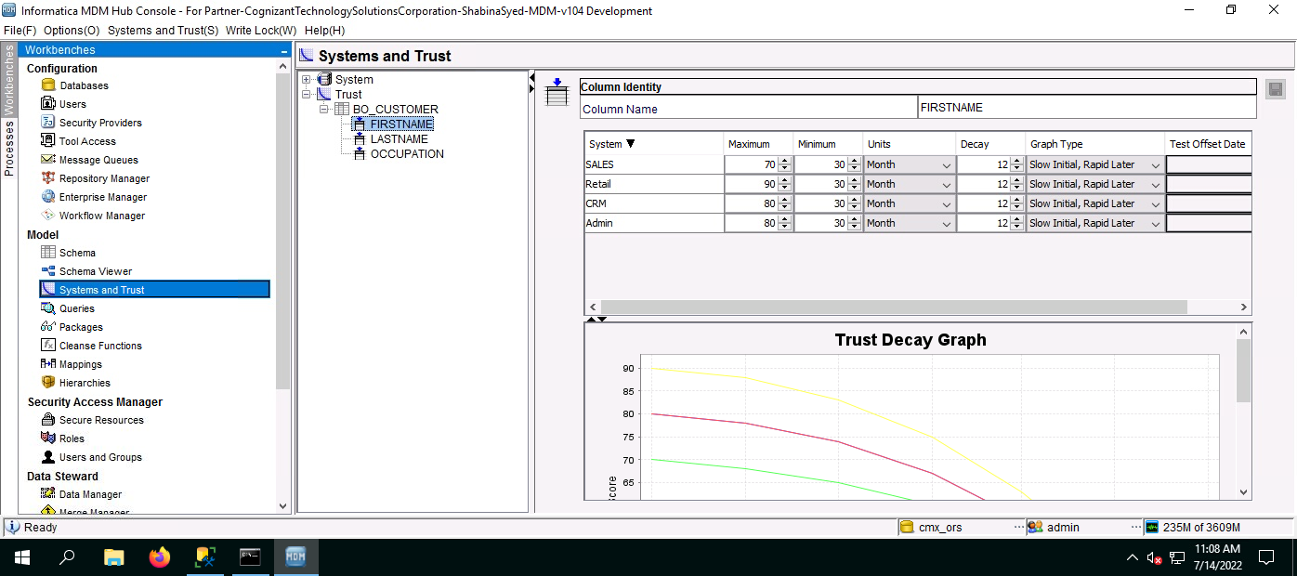

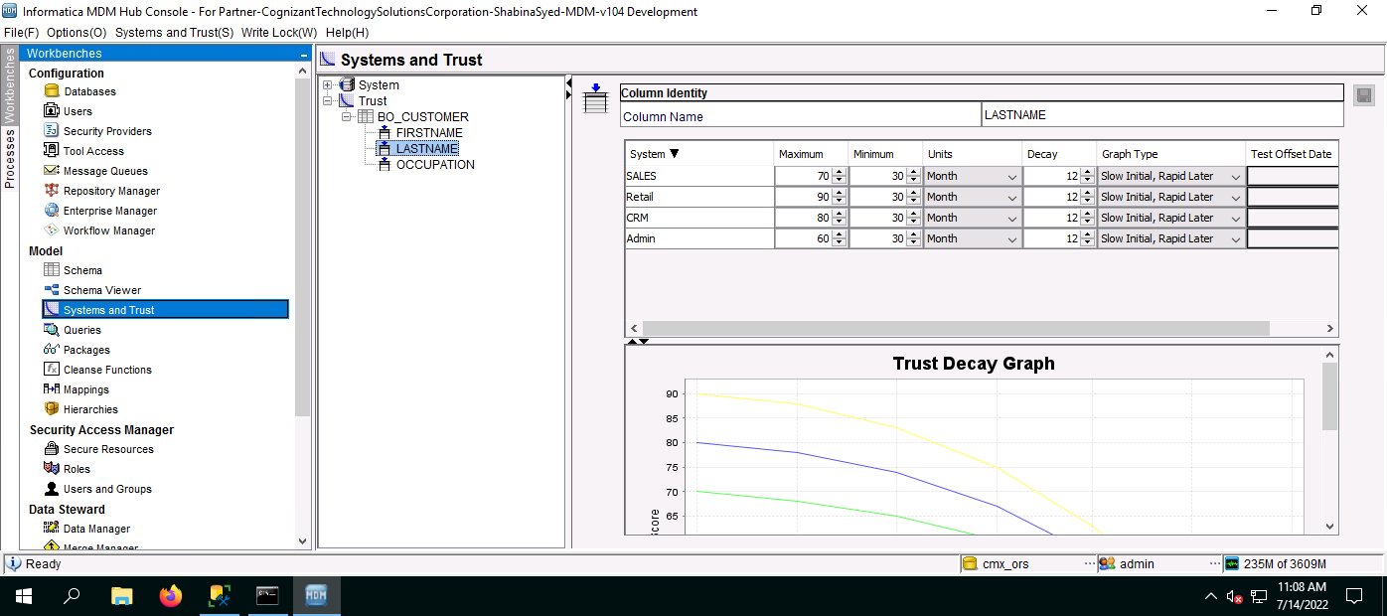

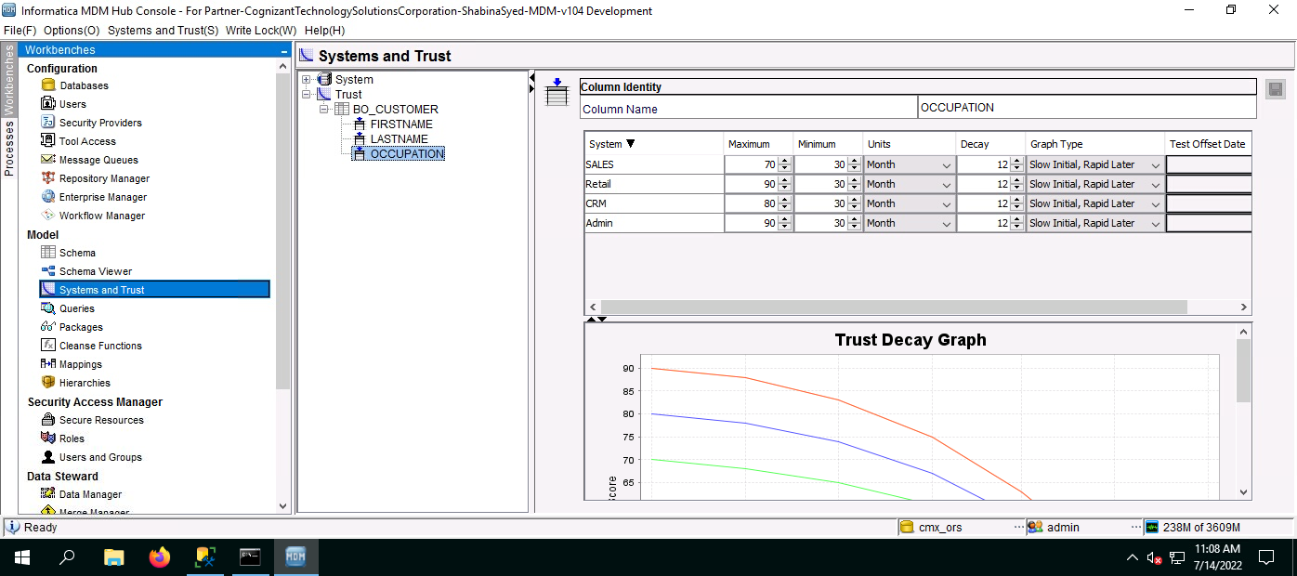

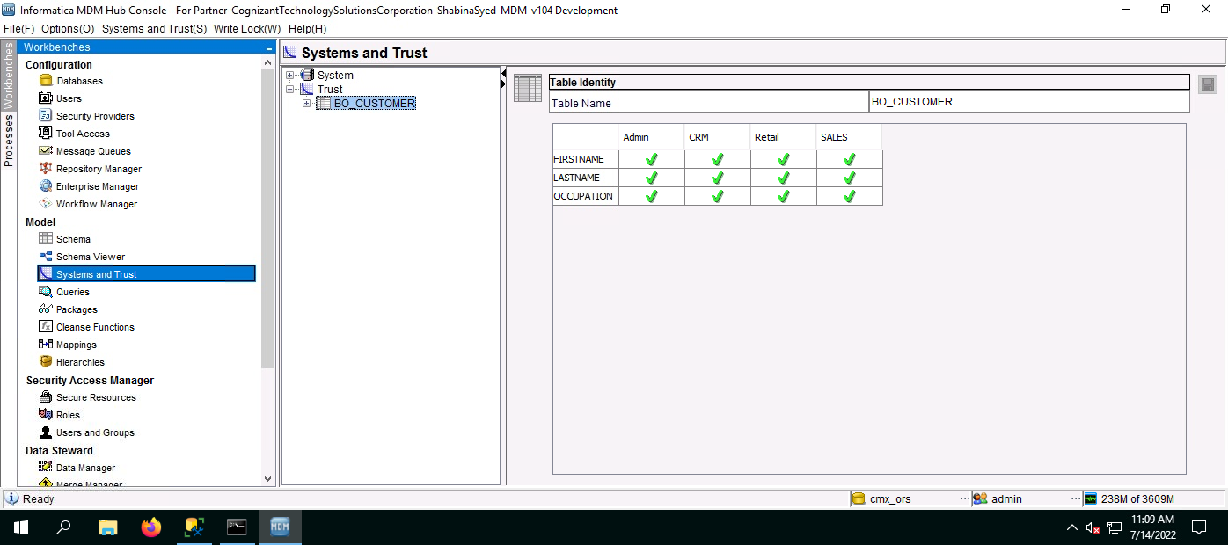

Fig: System and Trust

## 1.19 Queries and Packages:

Queries/Packages used in this project are defined below. The query is given totally.

|  |  |
| --- | --- |
| Sl no. |  |
| 1 | Putpkg(BO_CUSTOMER) |

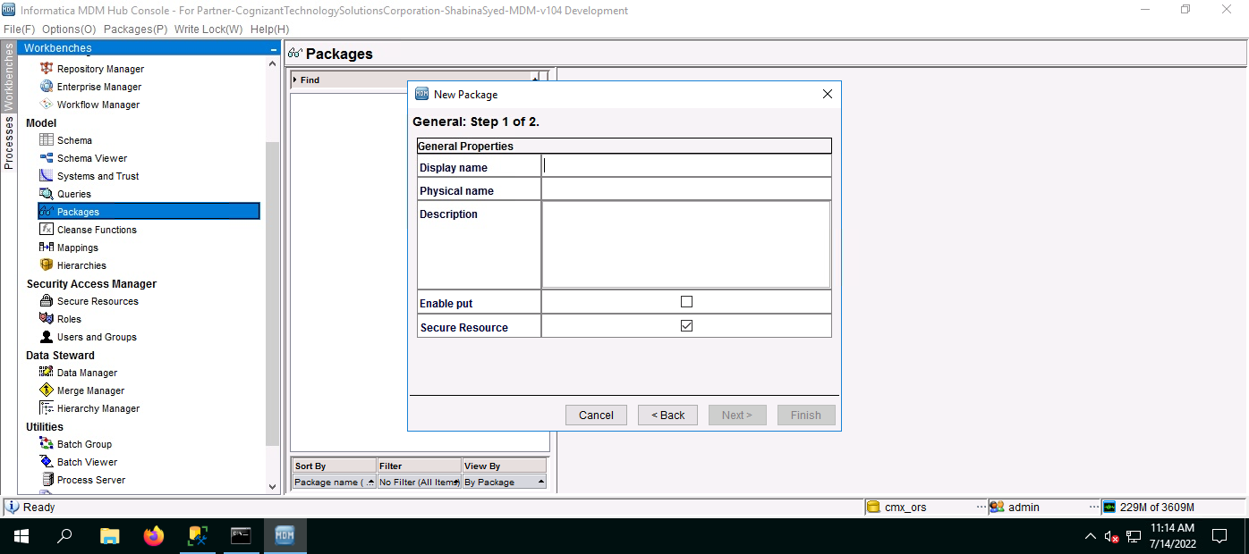

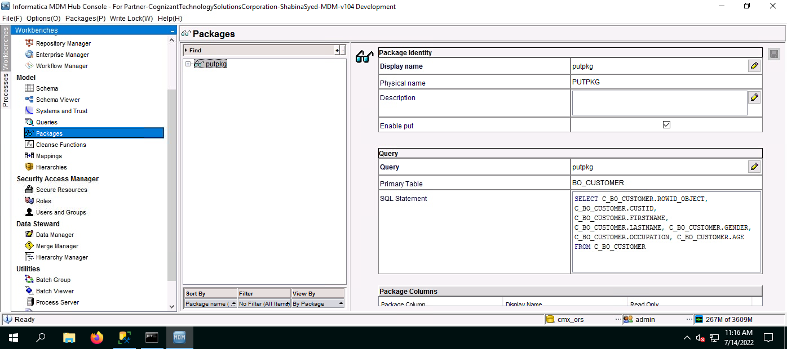

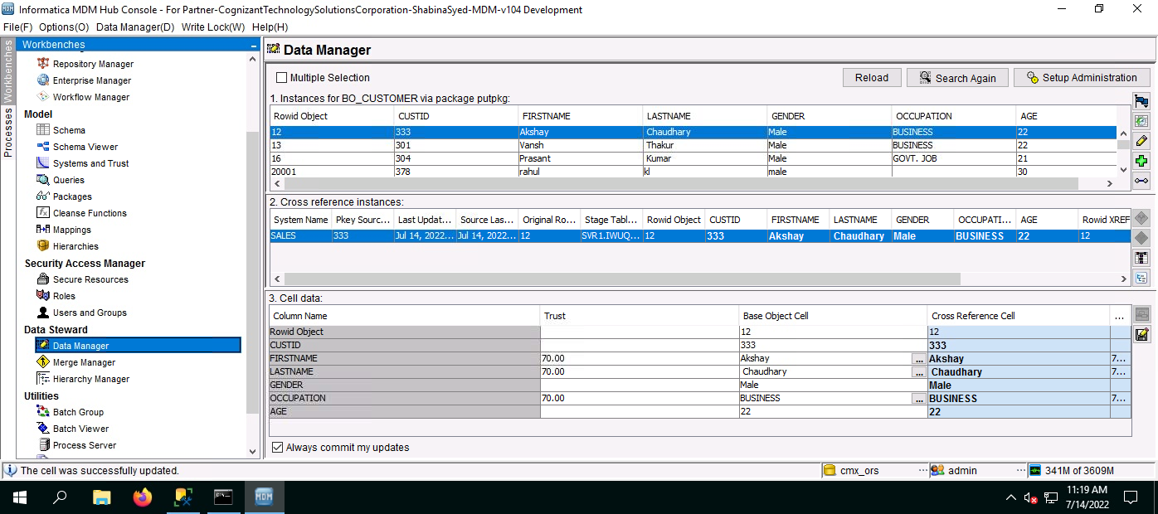

1.20 GOLDEN COPY

